Concept Down-Selection

Team 205 – Assistive Robotic Device for PPMD

09/27/2024

**Summary of Concepts:**

**Cavan Concepts:**

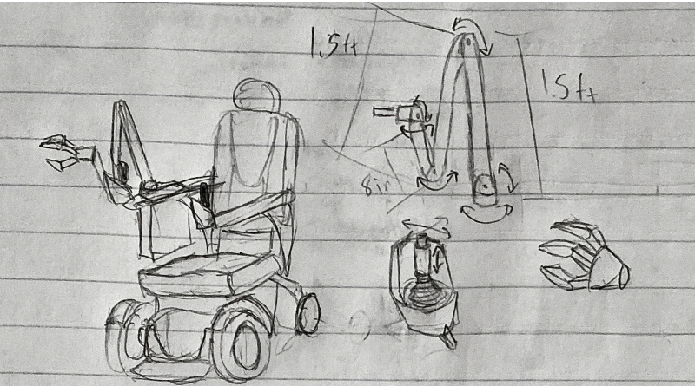

Figure 1: Forward Mounted Robotic Arm

Key Features: A robotic arm attecthed at the front of the wheelchair, controlled by a joystick.

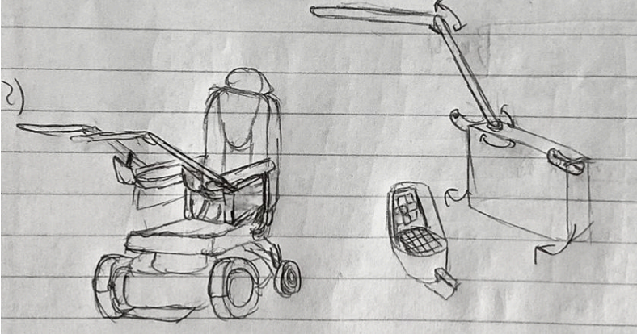

Figure 2: Dual Mechanical End Effectors

Key Features: Two arms that arm entirely mechanical and meant to interact with buttons, one on each side of the chair and controlled by a touch screen.

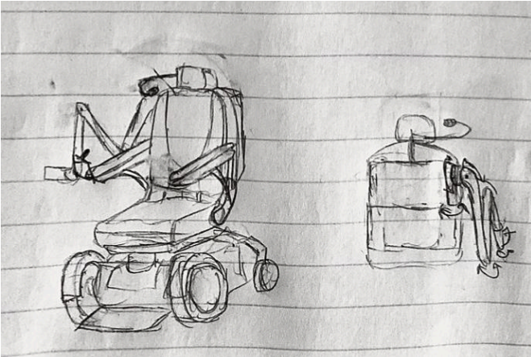

Figure 3: Shoulder Mounted Robotic Arm

Key Features: A robotic arm attached to the back of the wheelchair, controlled by a voice to text adapter with preset commands.

**Justin Concepts:**

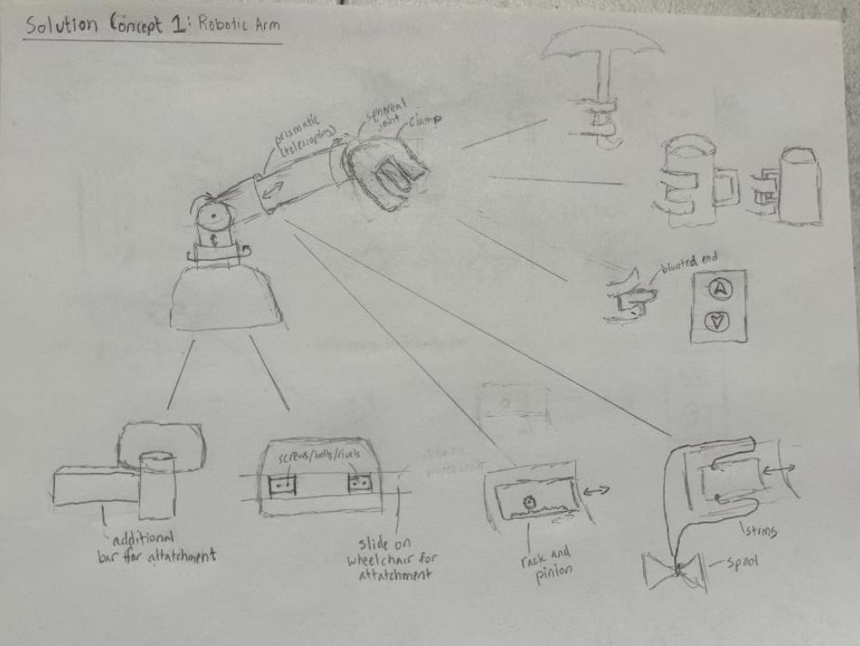

Figure 4: Robotic Arm

Key Features: A robotic arm with prismatic and revolute joints for extension and rotation.

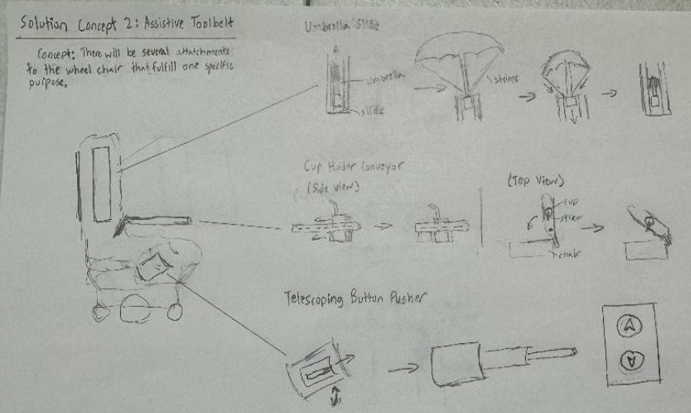

Figure 5: Assistive Toolbelt

Key Features: A series of separate mechanisms meant to fulfill one purpose placed in the most optimal position.

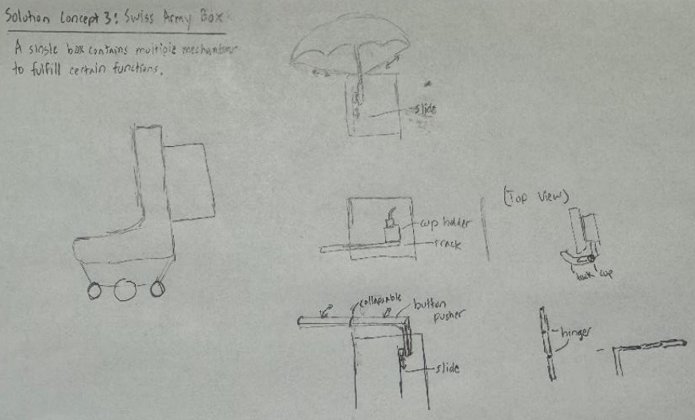

Figure 6: Swiss Army Box

Key Features: Box that contains mechanisms to fulfill multiple functions.

**Brooke Concepts:**

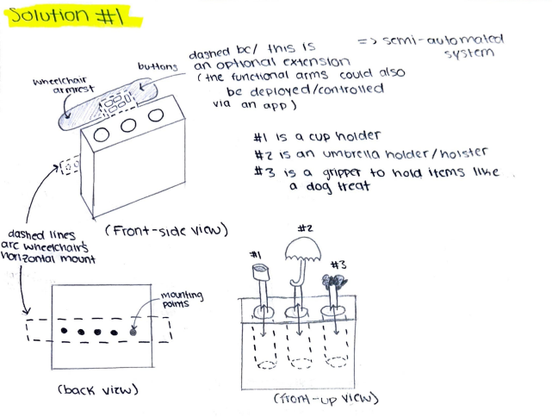

Figure 7: Equipment Box

Key features: Series of buttons that can deploy and holster up to three functional items

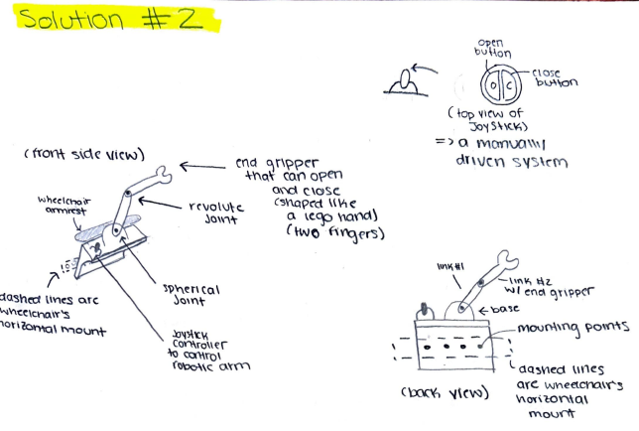

Figure 8: Robotic Arm (w/ spherical base joint)

Key features: A joystick-controlled, three linked (w/ revolute + spherical joints) robotic arm with an end-gripper than can open-close

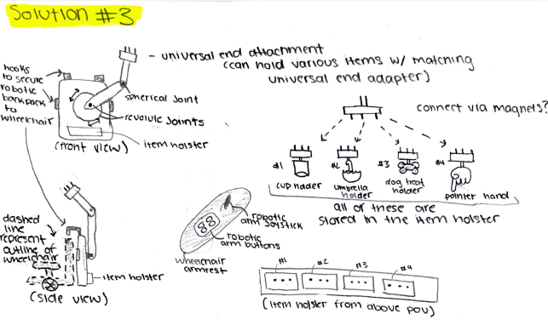

Figure 9: Robotic Backpack

Key features: A robotic arm mounted to the back of a power wheelchair with adaptable end effectors

**Omar Concepts:**

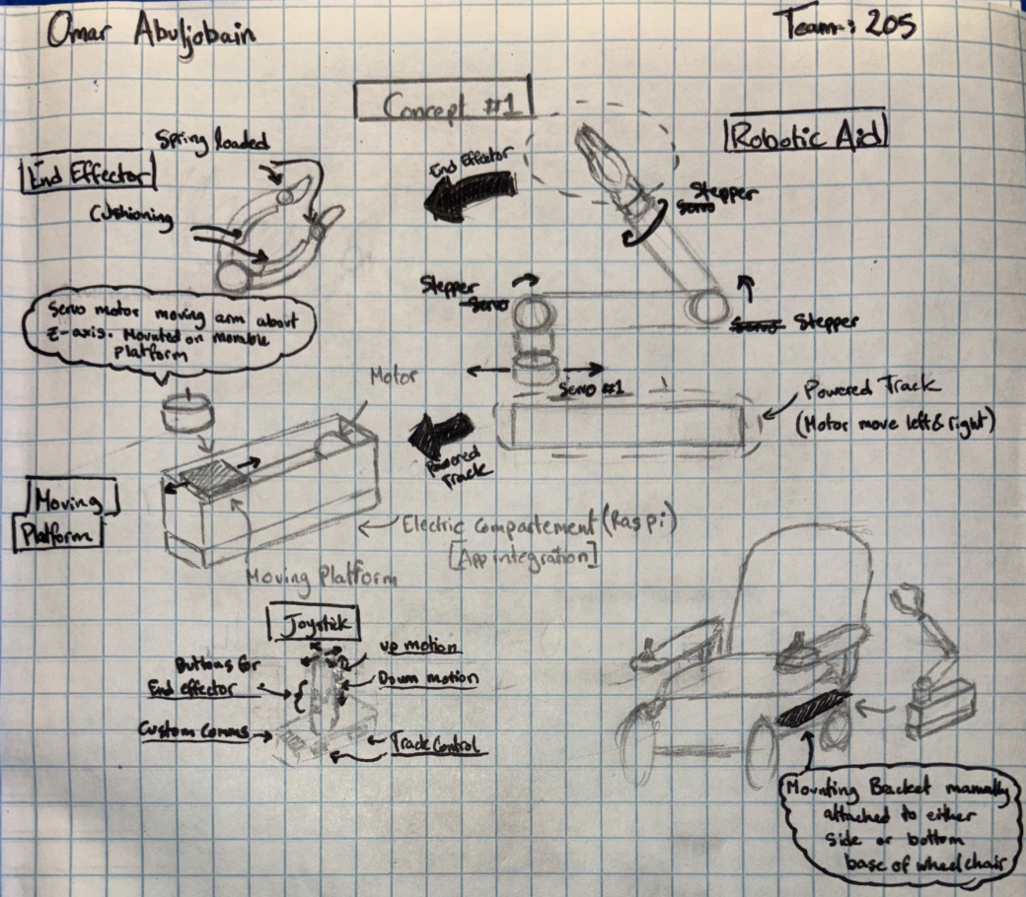

Figure 10: Motor Dependent Robotic Arm

Key Features: 4 DOF (excluding end effector) with prismatic motion (Via powered track) for additional range of motion.

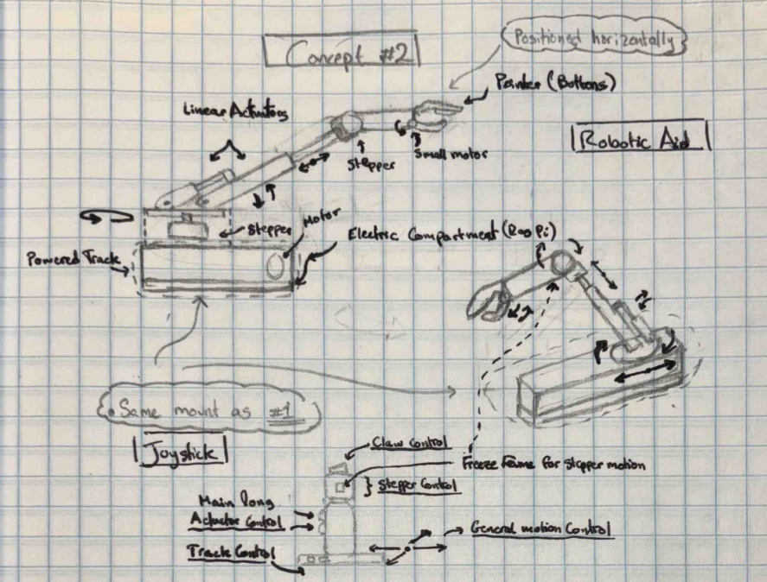

Figure 11: Actuator Dependent Robotic Arm

Key features: Motion actuated via linear actuators supplying additional force leaving less weight constraints on motors.

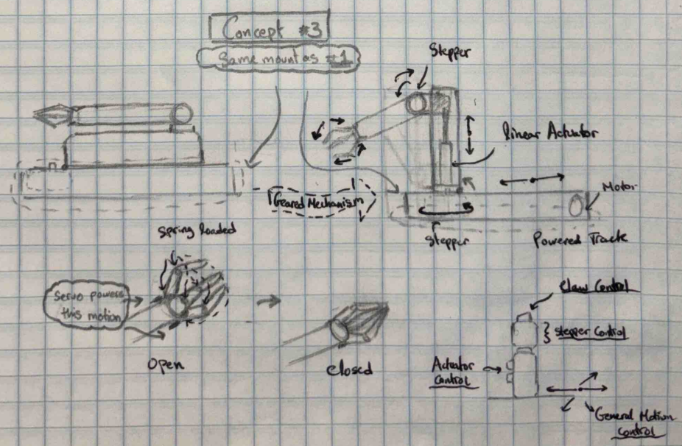

Figure 12: Prismatic Robotic Arm

Key features: 2 DOF are linear for compatibility and simplicity. (System contains 5 DOF excluding end effector)

**Andrew Concepts:**

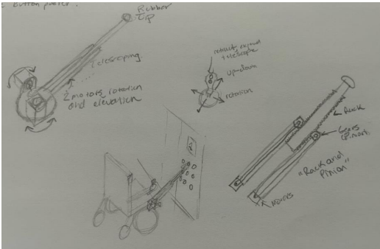

Figure 13: Button Pusher (Rack and Pinion).

Key features: Simplistic Joystick with three ways to control arm, two motors at the base to position arm

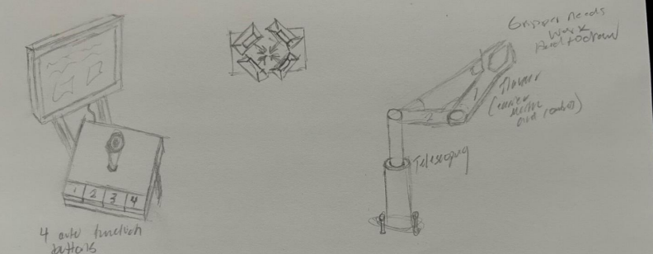

Figure 14: Robotic Arm with Telescoping Vertical Link

Key features: Two arm linkage, telescoping link used for vertical motion, four digit end effector

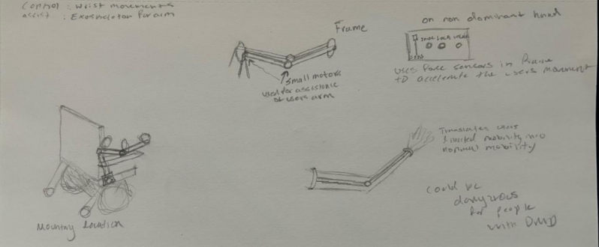

Figure 15: Exo Skeleton Motion Accelerator

Key features: Control panel to lock and unlock arm, lightweight frame, senses small user motions and accelerates them

**Selection Criteria:**

The selection criteria for team 205’s trade studies are derived from the needs and requirements of the customer. Through discussion with the customer, the system should be able to push an elevator button, push a handicap button, and grab objects such as a water bottle, spoon, fork, phone and tv remote.

The first criterion for the trade studies is span/operating radius of the solution. Since the device needs to push elevator buttons positioned on both the right and left sides of the elevators, the device needs to reach across the user to both sides. The team defined TR 1.3.0 as a robot with an operating radius that spans 5 inches to 2 feet and 180 degrees of rotation.

The second and third criterion for the trade studies is simplicity regarding the structure of the concepts and the controller (defined as number of actuators to control and number of inputs on control device). One of the team's requirements is that the device be controlled through a joystick mounted on the arm of the electric wheelchair (TR 1.1.0-1.1.2). Through the discussion with the sponsor, the team learned that operating a complex controller would prove difficult for people with muscular dystrophy, and that current solutions are unintuitive and hard to use. Therefore, the team needs a controller that is easy and intuitive to use. These criteria compare the ease of operation of each concept.

Additional criteria included size, cost, and safety. Since the device will provide a range of motion assistance it is necessary to compare the size and safety of each concept so that the user is not placed in danger. Cost is derived from the number of actuators, controller, size, electronics, material, and safety of concepts. Team 205 defined startup and operation safety requirements in the RVTM (TR 5.x.0). The team also added a failure modes criterion to evaluate risk levels among the different concepts for safety purposes. The safety criterion refers to safety when operating and the failure modes criterion refers to the “amount” or “likelihood” of something unexpected occurring (derived from number of moving/mechanical parts).

The last set of criteria are “device integration into chair” and “ease of installation”. Device integration into chair refers to the concepts’ ability to fit onto the chair without obstructing any necessary systems or impeding normal user experience. TR 1.1.3 is directly addressed through this criterion as these requirements state that the device should not interfere with the user's seating space and must be small enough that the user can pass through normal doors with the system installed. Ease of installation refers to TR 3.0.0 which sets a time frame for installation and operation. Concepts should be easily and quickly installed onto different chairs so optimal positioning for each person can be determined.

**Concept Screening Trade Study**

Team 205 met in Holden Hall at the 2nd floor whiteboards to begin the down selection process. The team first eliminated the exoskeleton concept as it required research on technology and design that would not fit within the budget or time frame. This concept also posed severe risk to the user if there were a malfunction. Additionally, multiple members created robotic arm concepts, utility backpack concepts, and “toolbelt” style concepts. Since there were duplicates, the team combined similar concepts to further reduce the concepts needing screening, resulting in six concepts to be screened: “Justin Omar Combo Robotic Arm”, “Brooke Cavan Combo Over the Shoulder Robot Arm/Backpack”, “Justin AJ Combo Assistive Toolbelt”, “Omar Track/Pneumatic Arm” , “Combo Utility Box (all in one)”, and “Brooke Multi End Effector”.

**Description of Concepts to be Screened**

**“Justin Omar Combo Robotic Arm”:** Standard robotic arm with a shoulder, elbow and wrist joint. Positioned in front of the user's dominant hand. Also includes the option of interchanging prismatic joints with more links and revolute joints for increased compatibility and range.

**“Brooke Cavan Combo Over the Shoulder Robot Arm/Backpack”:** Standard robotic arm mounted to the back of the electric wheelchair that operates over the shoulder of the user

**“Justin AJ Combo Assistive Toolbelt”:** Mounts specific functions (umbrella deployer, water bottle, buttons pusher) in optimal locations (on the back of the chair, at the armrest, under the armrest, respectively)

**“Omar Track/Pneumatic Arm”:** Robotic arm that uses a track to deploy and retract a robotic arm. The robotic arm focuses on power and uses pneumatics or electric actuators to generate motion.

**“Combo Utility Box (all in one)”:** Similar to the “toolbelt” however all the functions are contained in one housing and deployed from one location.

**“Brooke Multi End Effector”:** Robotic arm similar to the previous robotic arms however the end effector can be detached, and another can be attached that is designed for specific functions (such as button pusher, deploying an umbrella, holding a water bottle)

Concepts were deemed “non-viable” if they did not meet the derived requirements or could not meet the requirements within the allotted time or budget. The exoskeleton was eliminated as it would require significant amounts of research, design iteration, and testing which will not fit within the team's time schedule. Additionally, the double-arm design was eliminated as developing and integrating two arms onto the wheelchair would exceed the project timeline. The functions of the two-arm system could be combined into other solutions.

**Reference**

The reference was chosen by evaluating which concept most closely related to the functions of the human arm, which led the team to make the reference concept “Brooke Cavan Combo Over the Shoulder Robot Arm/Backpack”. Since the device should mimic the functionality of a human arm or provide specific functions a human arm could accomplish, the reference was chosen such that each concept had aspects that were better and worse than the reference, thus, the screening would produce accurate, reliable results.

**Concept Screening Table**

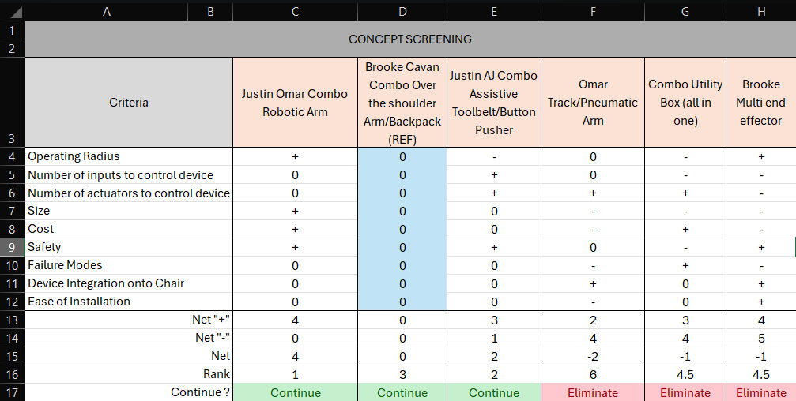

Figure 16. Concept Screening Results

No engineering calculations were made to determine the plus-minus-zero status. Rather, hypothetical designs were used to determine the value. For example, the number of actuators to control a robotic arm is 5-6 motors, with the baseline falling in this range. Therefore a “-” indicates the concept needs more motors and a “+” indicates the concept needs less. The “Combo Utility Box” and “Combo Assistive Toolbelt” both received a “+” because they would likely require less motors to perform the required functions of the customer. The team needs to acquire a motorized wheelchair and research off-the-shelf robotic devices before engineering calculations can be made regarding design choices.

The screening process determined that “Justin Omar Combo Robotic Arm”, “Brooke Cavan Combo Over the shoulder Arm/Backpack”, and “Justin AJ Combo Assistive Toolbelt/Button Pusher” would be the concepts that continue to the scoring process. These concepts were most feasible to build within the timeframe and met the criterion better than other solutions.

**Concept Scoring Trade Study:**

The reference remained the same from screening to scoring as the concept most closely relates to the physics of a human arm. This reference allows the weights in the scoring process to accurately determine which concepts should be developed and which should be eliminated.

The weights were determined based off customer statements about needs regarding the robotic aid. The most important need was that the solution be easy to control and fit within the existing footprint of the electric wheelchair, which is why “number of inputs to control” and “size” each received a 15% weight. Safety also received a 15% weight as the device is operating in proximity to the user and contains motors, structures, and electronics that could cause harm to the user if proper precautions are not taken. All other criteria received a 10% weight while “ease of installation” received a 5% as this is not as important as the other criteria; however, it should still be considered in the scoring.

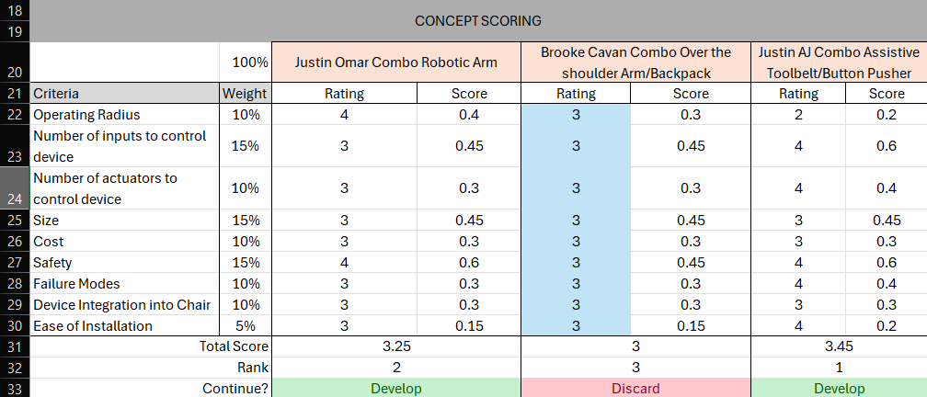

Figure 17. Concept Scoring Table

No engineering calculations were completed during the scoring section as the team is unsure if an off the shelf robotic aid will be purchased and modified or if it will be developed from scratch. Once the team meets with the customer to determine the final concept, the team will use engineering calculations to make informed design choices. The team must also acquire a motorized wheelchair before calculating as the physical structure and mounting locations need to be understood to mathematically model the physics properly.

The scoring process resulted in “Justin Omar Combo Robotic Arm” and “Justin AJ Combo Assistive Toolbelt” as the final two concepts. The team will take these two concepts to a meeting with the customer with the knowledge that one concept will specifically meet the high value functions the customer described, while the other concept might adequately meet the functions but will provide a free range of motion that can be used for tasks outside of the defined high value functions. The goal of the meeting is for the customer and team 205 to discuss the implications of both concepts, choose one concept to move forward with, and receive customer suggestions for the concept as we finalize our design.

**Attachments:**

|  |  |
| --- | --- |
| 1 | Concept Trade Studies.xlsx |
| 2 | RVTM – Team 205.xlsx |

1. Concept Trade Studies.xlsx

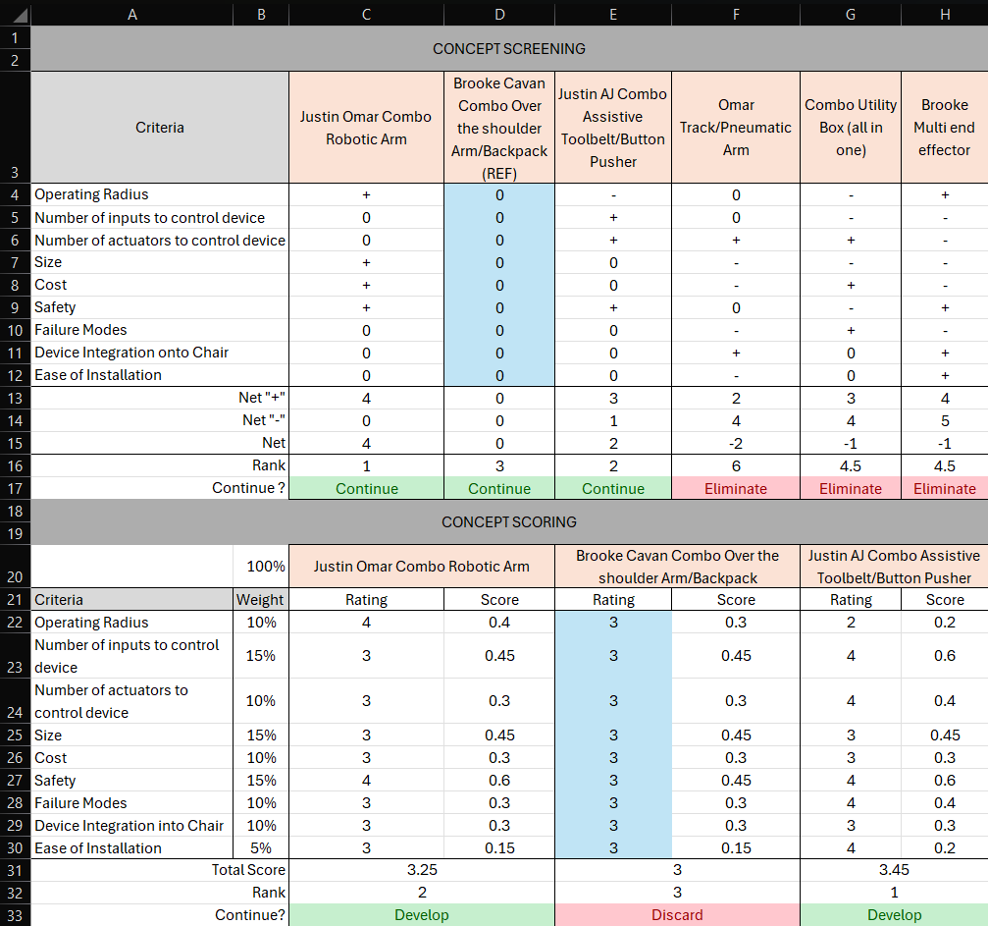

1. RVTM – Team 205.xlsx

